- We expect the Monetary Policy Committee will keep Bank Rate at 4.25% at its next meeting on June 19, and a vote split of 7-2. Recent data support the case for further easing, and should reduce the MPC's worries about inflation stickiness. But we don't think the data has been weak enough to prompt the committee to up the pace of cuts from the tempo seen since last August.
- The MPC's concerns about supply mean the pay and jobs data over the next couple of months will be key as the committee assesses how the labour market has responded to the April rises in employers' national insurance contributions and the national living wage. But given policy remains restrictive, we still expect two further 25bps cuts this year in August and November.
The Bank of England's Monetary Policy Committee cut Bank Rate by 25bps at its most recent meeting on May 8. Though the outcome was widely expected, the MPC's message was more hawkish than markets had anticipated. In part, this reflected the narrow three-way vote split. But the minutes also suggested there was no real appetite among the majority to support a faster pace of rate cuts anytime soon. Given this, and considering the data since the May meeting hasn't been especially weak, we think the committee will pause in June. The real interest will centre on the August meeting.
Every MPC member apart from Deputy Governor Sir Dave Ramsden has made public comments since the May meeting to clarify their positions (Table 1 shows our analysis of recent comments by MPC members). While there is agreement that the direction of travel for interest rates is downward, several camps have formed within the committee on the pace of cuts and (Chart 1).
Swati Dhingra and Alan Taylor – the MPC's most dovish members – followed up their votes for a larger 50bps cut in May by suggesting that they are likely to vote for another reduction at the June meeting. In particular, both view the risks to growth and inflation as being tilted to the downside due to weak domestic demand and the dampening effect of higher US tariffs.
Chart 1: How the views of Bailey, Lombardelli, and Ramsden evolve will be key to August's vote
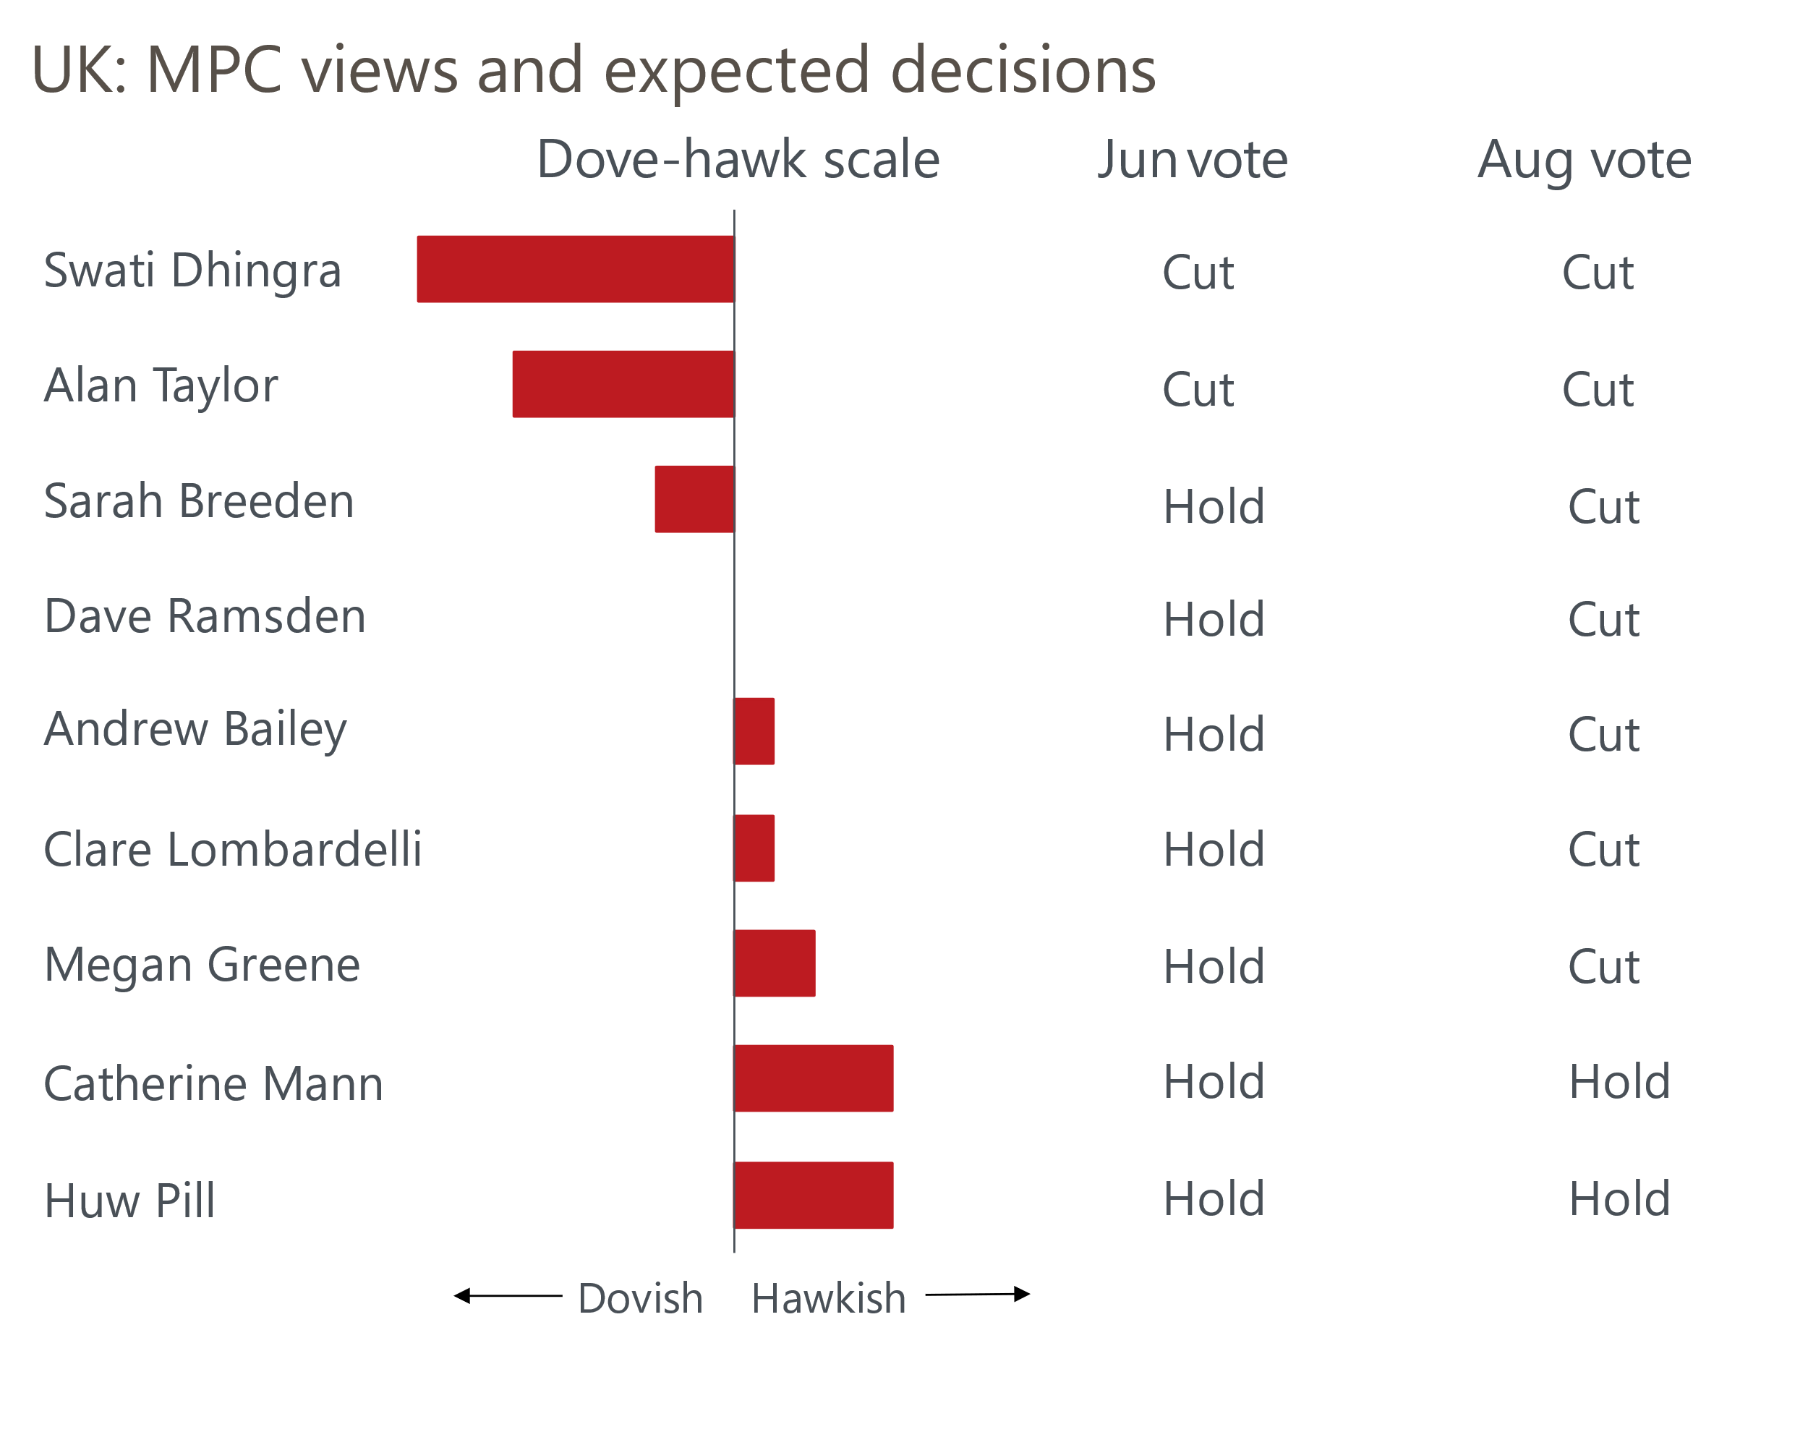
Source: Oxford Economics

At the more hawkish end of the spectrum, Chief Economist Huw Pill and external member Catherine Mann have characterised their votes for no change in May as a skip rather than a signal that they wanted to stop loosening policy entirely. But with Bank Rate now on a lower path than what either member deemed optimal at the previous meeting, it's difficult to envisage Pill and Mann voting for a cut soon.
Given Ramsden hasn't commented publicly since the May meeting, it's difficult to know where his views lie in relation to the rest of the committee. But among the other four members who voted for a 25bps cut in May, views are spread.
Governor Andrew Bailey, Deputy Governor Clare Lombardelli, and external member Megan Greene have all said they were undecided between cutting and holding Bank Rate ahead of the May meeting until the US announced the 'liberation day' tariffs in early April. In contrast, Deputy Governor Sarah Breeden singled herself out as being slightly more dovish than these three, remarking that despite trade developments, ongoing disinflation and labour market loosening meant she "would probably have voted to cut rates anyway" in May. Meanwhile, Greene has previously voiced significant concerns that the economy's weak supply side was perpetuating the persistence in price- and wage-setting. This suggests she is probably slightly more hawkish than Bailey and Lombardelli.

Recent data is unlikely to have derailed the MPC's cut-hold tempo
Data published since the May meeting should help to ease the MPC's worries about inflation stickiness. It has been broadly consistent with the committee maintaining its gradual approach to lowering Bank Rate.
April's CPI inflation reading came in 0.1ppts above the BoE's staff forecast, following a significant upside surprise in services inflation. However, this overshoot was primarily driven by an unusually large increase in the vehicle excise duty category, which the Office for National Statistics has since revealed was due to an error in the data supplied by the Department for Transport. CPI inflation should have been 3.4%, in line with the BoE staff's forecast.
April's rise in services prices was also exaggerated by a very high reading in the air fares category, as the month's collection dates coincided with the Easter holiday, unlike in 2024. The MPC's favoured measure of underlying services inflation, which excludes the impact of indexed and volatile components, continued to edge downwards in April (Chart 2).
Chart 2: CPI services inflation rose sharply but the BoE's measure of underlying services inflation cooled
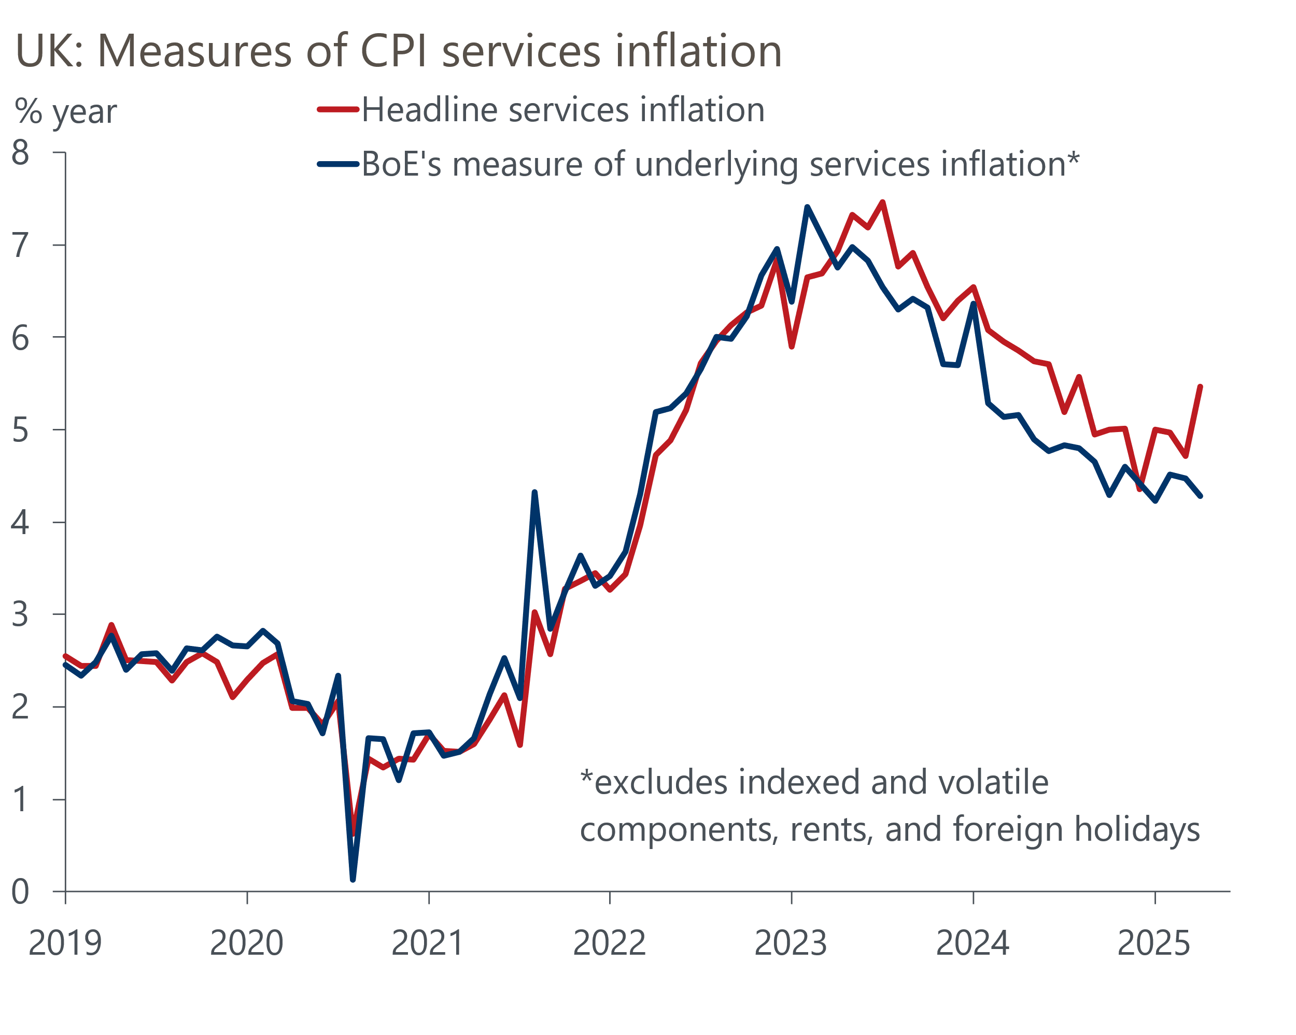
Source: Oxford Economics calculations using data from Haver Analytics
The labour market continues to loosen, reflecting a sustained period of modest underlying activity growth, alongside the increases in employers' national insurance contributions and the national living wage in April. The unemployment rate has started to pick up slightly in recent months. Though ongoing data quality concerns mean we place little weight on the ONS' official estimates of unemployment, the weaker picture is mirrored in alternative data. Most notably, HMRC reported a 109k fall in employees in May, which was the seventh successive monthly decline. The recent rise in labour costs and broader economic uncertainty has also weighed on hiring conditions, with job openings slipping further below their 2019 level.
Private sector regular pay growth of 5.1% in the three months to April was still well above the pace the MPC considers consistent with achieving the inflation target over the medium term. But the Q1 outturn was 0.2ppts lower than the BoE's staff forecast, and the series is tracking below the BoE's projection so far in Q2. This is a marked contrast to the previous period of overshooting pay growth, which had fuelled the MPC's worries about inflation persistence. The committee continues to anticipate further cooling over the rest of this year (Chart 3).
Chart 3: Pay growth is easing but remains well above a target-consistent pace
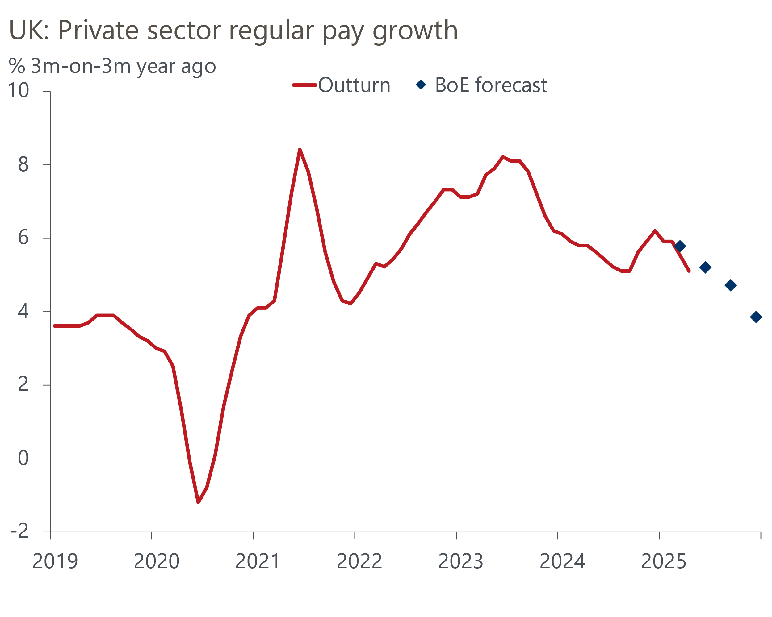
Source: Haver Analytics, Bank of England Monetary Policy Report
Turning to demand, GDP grew 0.7% quarter-on-quarter in Q1, which was slightly firmer than what the MPC had expected. While some of this strength unwound in April, we think there could be some further payback ahead. The expenditure breakdown suggested that Q1's expansion largely reflected substantial rises in business investment and net exports. The former was driven by aircraft purchases, while the latter tends to be volatile and the rise in Q1 was probably indicative of some last-minute stockpiling before US tariffs came into force. So there's a good chance that quarter-on-quarter GDP growth in Q2 is much softer than in Q1.
We also continue to believe that changes to seasonal spending patterns since the pandemic have resulted in artificially strong growth rates for GDP in the first half of the year and exaggerated weakness in H2. This suggests that activity growth is likely to be much slower over the rest of this year than in Q1. Still, we think GDP growth should outperform the MPC's expectations slightly in 2025.

A hold in June is almost certain, but labour market data will be key to the August meeting
The MPC has settled into a cut-hold tempo for policy loosening, and we think the likelihood that the committee will break from this pattern in June is very low. We anticipate a 7-2 vote to keep Bank Rate unchanged at 4.25% in June, with only Dhingra and Taylor likely to support a cut.
Of more interest than June's interest rate decision will be how the committee uses the minutes to communicate what it is focusing on ahead of the August meeting. We expect in the June minutes the MPC will retain its reference to taking a "gradual and careful" approach to loosening policy, reflecting the MPC's commitment to the current pace of rate cuts in the near term. We also would view any references to greater confidence that slack is emerging in the economy as a tacit indication that an August cut is the baseline view for a majority of committee members. The committee is likely to emphasise that the path for rates further ahead is more uncertain, as the outlook for global trade has become less predictable.
The acute uncertainty has manifested itself in a significant divergence of views on the MPC. With two members at either end of the dove-hawk spectrum, and Breeden and Greene leaning in opposite directions, it's clear that the views of Bailey, Lombardelli, and Ramsden will determine the pace of cuts at future meetings (Chart 1).
Key to the decision-making process of these three members will be whether there is any evidence of further price and wage persistence in next month's labour market release and the two sets of inflation figures that the committee will see before the August meeting. Indeed, Governor Bailey recently said that for interest rates to continue to fall, it would be "crucial" that wage growth comes down.
Given policy is still comfortably in restrictive territory, concerns about the durability of demand remain and our forecast assumes some easing in pay growth in the coming months, we continue to expect 25bps cuts in August and November this year. Financial markets broadly agree with our outlook this year, with current pricing implying a 78% chance of a cut in August and 53bps of cuts in H2 2025.
Table 1: Key comments by MPC members since the May meeting
Speaker and link | Date | Key takeaway
Greene | June 6 | Greene said that ongoing disinflation and US tariff increases led her to vote for a cut in May. In a recent interview, she also reiterated her previous concerns that sticky price and wage pressures could be driven by weak supply rather than subdued demand, which would warrant a more cautious approach to loosening policy.
Bailey | June 3 | At this month's Treasury Select Committee hearing, the Governor also said that he was part of the group who were undecided going into May's vote until the tariff news emerged from the US. Bailey also noted that the key question for him is whether pay growth comes down this year, and that the downward path for wages outlined in the BoE's Agents survey at the start of this year remains intact at the moment.
Breeden | June 3 | Breeden argued that she saw a case for a cut in Bank Rate in May even without the international developments. This was based on her judgement that the domestic disinflationary process was progressing as she had expected and that it would continue given spare capacity was opening up in the labour market.
Dhingra | June 3 | Dhingra remarked that risks to both growth and inflation appear to be tilted to the downside and warned of the dampening effect of changes in US tariffs. She also said that continued weakness in consumer spending and business investment suggests there is sufficient room to alleviate monetary restriction without risking second-round effects.
Mann | June 3 | Mann suggested that her vote to keep Bank Rate unchanged in May was motivated by firms' strong pricing power and a view that the easing in financial conditions after recent US tariff announcements was excessive. Still, she conceded that the direction of travel for interest rates remained downwards.
Taylor | May 29 | Taylor argued that he sees more risk piling up on the downside scenario outlined in May's Monetary Policy Report because of global developments. Though he did not explicitly say he would vote for a cut in June, he said his dissent in June indicates his view that Bank Rate needed to be on a lower path.
Pill | May 20 | Pill characterised his opposition to May's rate cut as a skip rather, rather than a signal that he wanted to stop loosening entirely. This is based on his view that structural changes in price- and wage-setting behaviour have increased the intrinsic persistence of inflation. Therefore, he advocated a more cautious pace of cuts than the quarterly 25bps reductions implemented by the MPC since August 2024
Lombardelli | May 12 | At the Bank of England watcher's conference last month, Lombardelli said that ahead of the May meeting she was balanced between holding and cutting Bank Rate, but gradual progress on disinflation and trade developments tipped the balance in favour of a 25bps cut. She also suggested that domestic price pressures, rather than US tariffs, were the biggest influence on her reading of the outlook.
Source: Oxford Economics

